**REGex Software Services**

**Java Full Stack Development Program**

Registration I'd:  **IIPRSS1404**

Name: **Shanmukh Subhash Kumbhar**

# Subject: Assignment 14 - #Multi-threading II

Core Java 2021 **Core Java Session 14 Assignments**

**Assignment 1:**

Develop a Program using join() method.

Develop 3 threads like **RedSignalThread, YellowSignalThread**, and **GreenSignalThread**. Order of execution must be

1. **RedSignalThread**

2. **YellowSignalThread**

3. **GreenSignalThread**

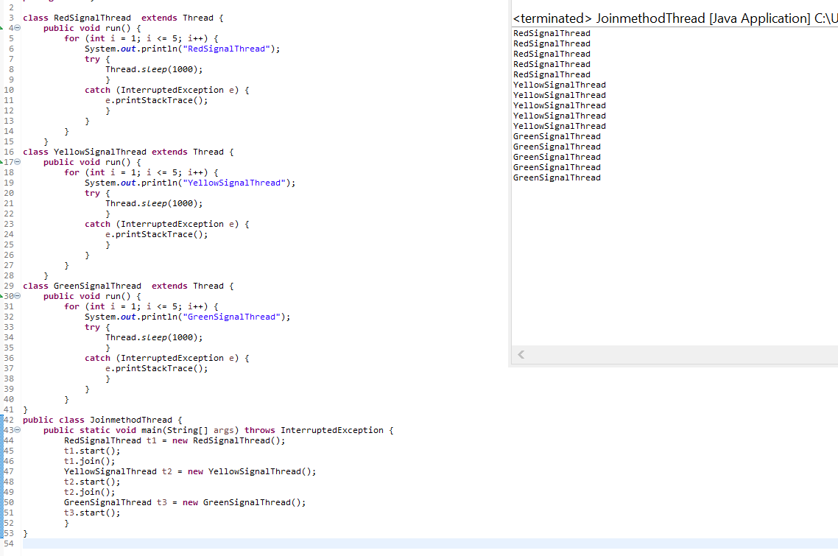

**Assignment 2:**

Develop a Program to implement synchronous concept?

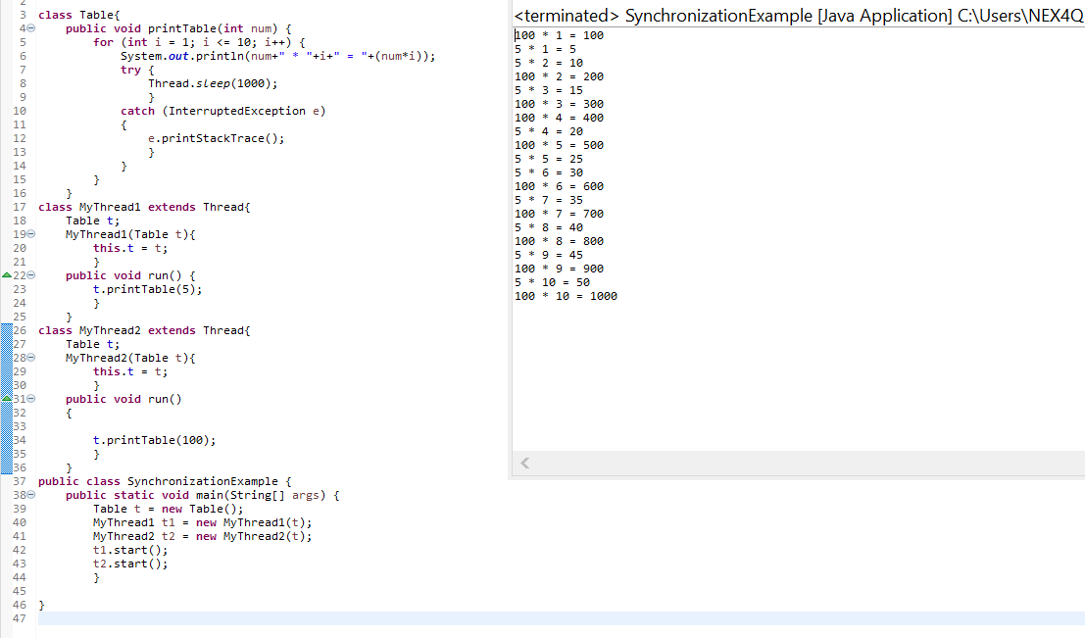

**Assignment 3:**

Develop a Program to implement inter-thread communication.

